BREAKFAST CHATTER
Weekly Bulletin of Rotary Club of Kathmandu Mid-Town
District 3290 Volume No. 15/38 for #780 April 15, 2005
www.rotarymidtown.org.np
APRIL IS THE MAGAZINE MONTH
Yes! We have a Happy Birthday for Rabindra ☺ ☺ ☺
****************
MEETINGS & ACTIVITIES:

DATE | ACTIVITY | SUBJECT
15 APR | ROBIN BRADSHAW  (IN PERSON) | LONDON TO CAPETOWN AND BACK BY SCOOTER  (IN HIS YOUTH)
22 APR | CLUB ASSEMBLY | PROGRESS REPORTS
23 APR | CLUB PICNIC | the MIRABEL IN DHULIKHEL
27 APR | BOARD MEEETING | NEIL HOSTING
29 APR | SOM PANERU | OVERCOMING KAMLARIA
06 May | open
13 May | open
20 May | AMOD MANI DIXIT | DO THIS BEFORE TOMORROW’S EARTHQUAKE
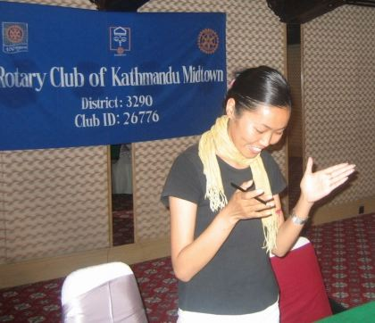
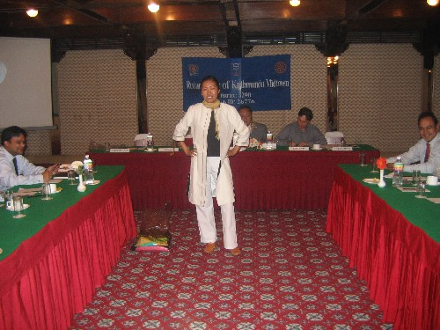
Our Speaker: Last Friday we had the pleasure of hearing from one of Kathmandu’s young entrepreneurs – Pema Khando – who is applying her design talent to women’s clothing for Europe. She modeled several items which showed us how one can blend Himalayan design characteristics into modern fashion. Her shop, Himalayan Couture is on Tridevi Marg. → → → ******

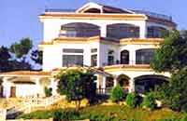

Our speaker this Friday is our traveling emissary, and sometimes Bankok resident, Robin Bradshaw, returned by popular acclaim to tell us of his youthful flight by motor scooter the length of Africa. ****** And Next Week, on the 23rd, will be the long-awaited but never-yet arrived Club Picnic. Just to build up your hopes, shown here are two lovely pictures of the Mirabel— destination for the Picnic.

******.

Hope to see you on Friday morning. YIR…David

